Aplia Homework: Supply and Demand: An Initial Look Part-1 Week-4

1. Movements along versus shifts of demand and supply curves
The following two graphs depict the market for peanut butter.
On the first graph that follows, show the effect of a shift of the entire demand curve resulting from consumers wanting to buy more peanut butter at every given price.
Note: Select and drag the curve to the desired position. The curve will snap into position, so if you try to move the curve and it snaps back to its original position, just drag it a little farther.

On the next graph, show the effect of a movement along a fixed demand curve that results from a decrease in the price of peanut butter, with every other factor held constant.

Complete the following table by indicating whether each event will cause a movement along the demand curve for peanut butter or a shift of the demand curve for peanut butter, holding all else constant.
Event | Movement Along | Shift
An increase in the number of consumers | _______ | ______
An increase in the price of peanut butter | _______ | ______
A change in tastes of consumers that makes them desire more peanut butter | _______ | ______

2. A demand puzzle
The following graph shows the demand curve for galumph, a useful commodity produced on the planet Hermes. The Hermetical currency is the yen. The graph input tool also shows how demand for galumph is affected by changes in the average income of Hermetians, as well as the prices of beam and frab, two other related goods available on the planet.
Use the graph input tool to help you answer the following questions. You will not be graded on any changes you make to this graph.
Note: Once you enter a value in a white field, the graph and any corresponding amounts in each grey field will change accordingly.
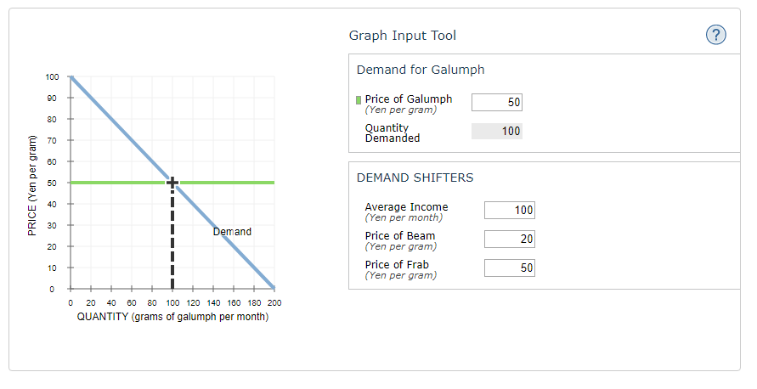
Suppose that the price of a gram of galumph decreased from 50 yen to 45 yen. This would cause a________ the demand curve and therefore an increase in__________.

Plug any value lower than the current number into the Average Income box. A decrease in average income causes a leftward_________ the demand curve.

When the prices of beam or frab change, there is a shift of the demand curve for galumph. The directions of these changes imply that frab and galumph are__________ , and that beam and galumph are_________ . For example, a Hermetian might say, “I went to eat my galumph this morning, but there wasn't any________ in my fridge. So instead of having galumph for breakfast, I ate some_______ .”

3. Changes in the supply of sedans
The following graph shows the supply curve for sedans in an imaginary market. For simplicity, assume that all sedans are identical and sell for the same price. Two factors that affect the supply of sedans are the level of technical knowledge—in this case, the speed with which manufacturing robots can fasten bolts, or robot speed—and the wage rate that auto manufacturers must pay their employees. Initially, the graph shows the supply curve when robots can fasten 2,500 bolts per hour and autoworkers earn $25 per hour.
Use the graph input tool to help you answer the following questions. You will not be graded on any changes you make to this graph.
Note: Once you enter a value in a white field, the graph and any corresponding amounts in each grey field will change accordingly.
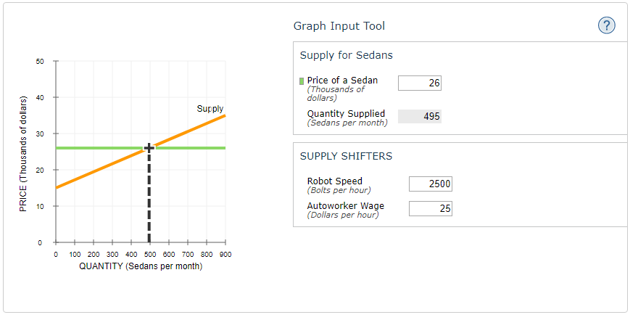
Suppose that the price of a sedan decreases from $26,000 to $21,000. This would cause the quantity supplied of sedans to_________ , which is reflected on the graph by a________ the supply curve.

Suppose the workers' union accepts a pay cut. This causes a_________ the supply curve because the pay cut makes cars_________

4. Market equilibrium

The following table shows the annual demand and supply in the market for orange juice in Denver.
Price | Quantity Demanded | Quantity Supplied
(Dollars per gallon of orange juice) | (Gallons of orange juice) | (Gallons of orange juice)
2 | 500 | 50
4 | 400 | 150
6 | 300 | 200
8 | 200 | 300
10 | 100 | 450
Based on the preceding table, plot the demand for orange juice on the following graph using the blue points (circle symbol). Next, plot the supply of orange juice using the orange points (square symbol). Finally, use the black point (plus symbol) to indicate the equilibrium price and quantity in the market for orange juice.

5. Market equilibrium and disequilibrium
The following graph shows the monthly demand and supply curves in the market for calendars.
Use the graph input tool to help you answer the following questions. Enter an amount into the Price field to see the quantity demanded and quantity supplied at that price. You will not be graded on any changes you make to this graph.
Note: Once you enter a value in a white field, the graph and any corresponding amounts in each grey field will change accordingly.
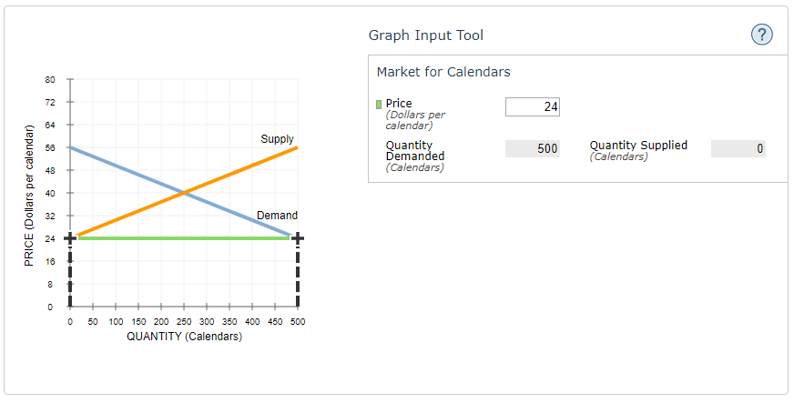
.
The equilibrium price in this market is ______ per calendar, and the equilibrium quantity is______ Calendars bought and sold per month.

Complete the following table by indicating at each price whether there is a shortage or surplus in the market, the amount of that shortage or surplus, and whether this places upward or downward pressure on prices.
Price | Shortage or Surplus | Shortage or Surplus Amount | Pressure on Price
(Dollars per calendar) |  | (Calendars)
48 | __________ | 250 | ___________
32 | __________ | 250 | __________

6. Shifts in supply or demand I
The following graph shows the market for peanut butter in Houston, where there are over a thousand stores that sell peanut butter at any given moment. Suppose the Surgeon General issues a public statement saying that consuming peanut butter is good for your health.
Show the effect of this change on the market for peanut butter by shifting one or both of the curves on the following graph, holding all else constant.
Note: Select and drag one or both of the curves to the desired position. Curves will snap into position, so if you try to move a curve and it snaps back to its original position, just drag it a little farther.

7. Shifts in supply or demand II
The following graph shows the market for pizzas in San Diego, where there are over a thousand pizza restaurants at any given moment. Suppose the number of pizza restaurants increases significantly.
Show the effect of this change on the market for pizzas by shifting one or both of the curves on the following graph, holding all else constant.
Note: Select and drag one or both of the curves to the desired position. Curves will snap into position, so if you try to move a curve and it snaps back to its original position, just drag it a little farther.

8. Another supply and demand puzzle
The market price of cheeseburgers in a college town decreased recently, and the students in an economics class are debating the cause of the price decrease. Some students suggest that the price decreased because a new type of grill enables restaurants to cook a cheeseburger in half the time. Other students attribute the decrease in the price of cheeseburgers to a recent decrease in the price of calzones at local pizza parlors. Everyone agrees that the decrease in the price of calzones was caused by a recent decrease in the price of pizza dough, which is not generally used in making cheeseburgers. Assume that burger joints and pizza parlors are entirely separate entities—that is, there aren't places that serve both cheeseburgers and calzones.
The first group of students thinks the reason for the decrease in the price of cheeseburgers is that a new type of grill enables restaurants to cook a cheeseburger in half the time.
On the following graph, adjust the supply and demand curves to illustrate the first group’s explanation for the decrease in the price of cheeseburgers.
Note: Select and drag one or both of the curves to the desired position. Curves will snap into position, so if you try to move a curve and it snaps back to its original position, just drag it a little farther.

The second group of students attributes the decrease in the price of cheeseburgers to the decrease in the price of calzones at local pizza parlours.
On the following graph, adjust the supply and demand curves to illustrate the second group’s explanation for the decrease in the price of cheeseburgers.

Suppose that both of the causes suggested by the students are partly responsible for the decrease in the price of cheeseburgers. Based on your analysis of the explanations offered by the two groups of students, how would you figure out which of the possible causes is the dominant cause of the decrease in the price of cheeseburgers?
_________________.
9. Effect of a tax on buyers and sellers
The following graph shows the daily market for shoes when the tax on sellers is set at $0 per pair.
Suppose the government institutes a tax of $23.20 per pair, to be paid by the seller.
Use the graph input tool to help you answer the following questions. You will not be graded on any changes you make to this graph.
Note: Once you enter a value in a white field, the graph and any corresponding amounts in each grey field will change accordingly.
Hint: To see the impact of the tax, first enter the value of the tax in the Tax on Sellers field. Adjust the value in the price field to move the green line to the after-tax equilibrium so that quantity demanded equals quantity supplied.
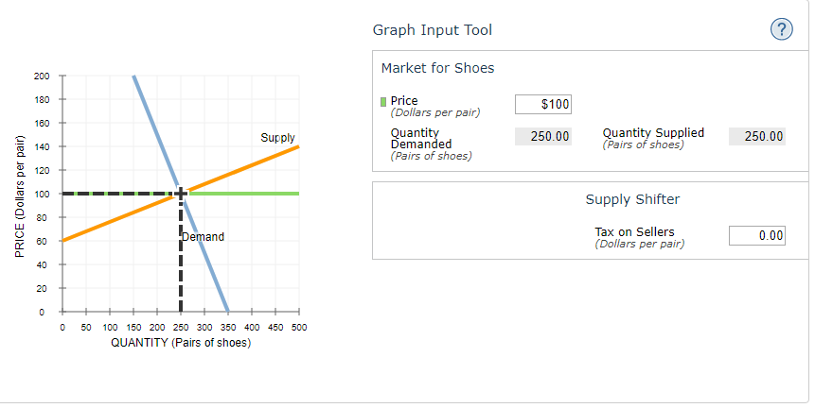

Fill in the following table with the quantity sold and the equilibrium price before and after the tax.
 | Quantity | Equilibrium Price
 | (Pairs of shoes) | (Dollars per pair)
Before Tax | _________ | ________
After Tax | _________ | ________
Points:
1 / 1

Although the tax was $23.20 per pair, after the tax was imposed, the equilibrium price increased by_______, which represents the amount of the per-unit tax that is paid by the buyers. From this you can conclude that sellers pay the remaining_______ of the $23.20-per-unit tax.

10. Price controls in the Florida orange market
The following graph shows the annual market for Florida oranges, which are sold in units of 90-pound boxes.
Use the graph input tool to help you answer the following questions. You will not be graded on any changes you make to this graph.
Note: Once you enter a value in a white field, the graph and any corresponding amounts in each grey field will change accordingly.
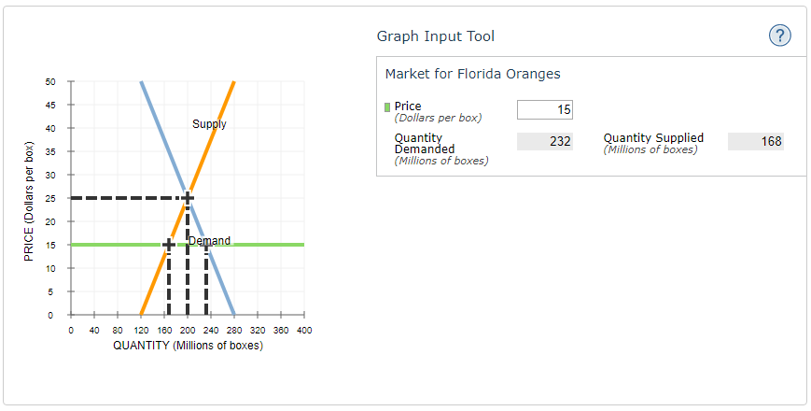

In this market, the equilibrium price is_____ per box, and the equilibrium quantity of oranges is______ million boxes.

For each price listed in the following table, determine the quantity of oranges demanded, the quantity of oranges supplied, and the direction of pressure exerted on prices in the absence of any price controls.
Price | Quantity Demanded | Quantity Supplied | Shortage or Surplus | Pressure on Prices
(Dollars per box) | (Millions of boxes) | (Millions of boxes)
30 | ________ | ________ | _______ | ________
20 | ________ | ________ | _______ | ________

True or False: A price ceiling below $25 per box is a binding price ceiling in this market. (Hint: Economists call a price ceiling that prevents the market from reaching equilibrium a binding price ceiling.)
_________.

Because it takes many years before newly planted orange trees bear fruit, the supply curve in the short run is almost vertical. In the long run, farmers can decide whether to plant oranges on their land, to plant something else, or to sell their land altogether. Therefore, the long-run supply of oranges is much more price sensitive than the short-run supply of oranges.
Assuming that the long-run demand for oranges is the same as the short-run demand, you would expect a binding price ceiling to result in a_______ that is_______ in the long run than in the short run.

11. Minimum wage legislation
The following graph shows the labour market in the fast-food industry in the fictional town of Supersize City. In a labour market, workers supply their labour to the market in exchange for wages, and their behaviour is represented by the supply curve. Similarly, firms pay wages to obtain labour, and thus their behaviour is represented by the demand curve. In this way, wages are the price of labour.
Use the graph input tool to help you answer the following questions. You will not be graded on any changes you make to this graph.
Note: Once you enter a value in a white field, the graph and any corresponding amounts in each grey field will change accordingly.

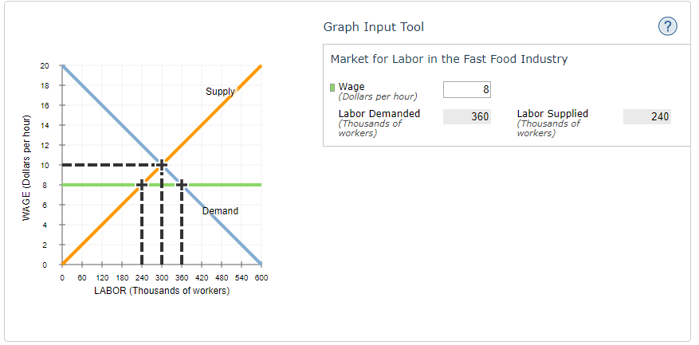

In this market, the equilibrium hourly wage is____, and the equilibrium quantity of labour is _____ thousand workers.

Suppose a senator introduces a bill to legislate a minimum hourly wage of $8. This type of price control is called a________ .

For each of the wages listed in the following table, determine the quantity of labour demanded, the quantity of labour supplied, and the direction of pressure exerted on wages in the absence of any price controls.
Wage | Labour Demanded | Labour Supplied | Surplus or Shortage of Labour | Pressure on Wages
(Dollars per hour) | (Thousands of workers) | (Thousands of workers)
6 | _______ | ________ | _______ | _______
14 | _______ | ________ | _______ | _______
Points:
1 / 1
Open Explanation
Explanation:
True or False: A minimum wage above $10 per hour is not a binding minimum wage in this market. (Hint: Economists call a minimum wage that prevents the labour market from reaching equilibrium a binding minimum wage.)
________.

12. Effects of price controls
Price floors and price supports set a minimum price below which a good or service cannot be sold. Minimum wage laws and agricultural price supports are common examples of such price controls.
When price floors are used to keep prices above free-market levels in the agricultural industry, which of the following outcomes are common? Check all that apply.
Overinvestment in the agricultural industry
A decrease in the future supply of agricultural goods
A problem of disposal of surplus agricultural goods
Efficient use of farms and land

